[Hooks Methods in Webdynpro for ABAP](https://wiki.scn.sap.com/wiki/display/WDABAP/Hooks+Methods+in+Webdynpro+for+ABAP)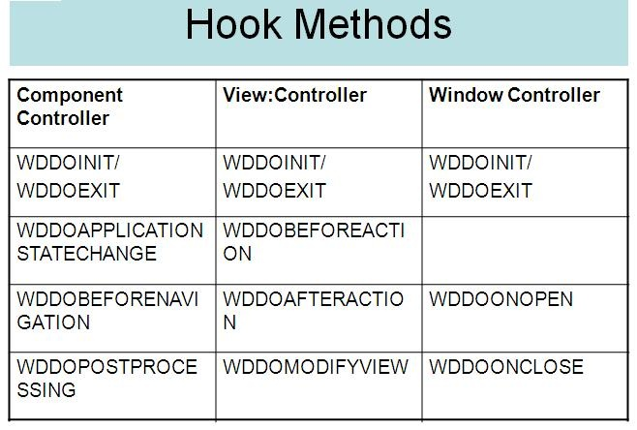

**WDDOPOSTPROCESSING**

•          This method is called in the last process step before rendering. Therefore, it allows you to add application-specific clean-up processes

**WDDOBEFORENAVIGATION**

•          The method WDDOBEFORENAVIGATION can be used to perform an additional validation of those controller contexts that are required in the application but have not been validated in the request/response cycle yet .

•          This method can only be used for the component controller

**WDDOAFTERACTION**

•          This method is called for all visible views at the time an action is executed.

•          Here functions can be placed that are carried out equally for all associated event handlers.

**WDDOBEFOREACTION**

•          Before an action is triggered, you can perform your own validations using this method.

•          The method can only be used for view controllers.

•          It is used for all visible views of the component assigned to the current phase model instance. These include all embedded components

**WDDOOPEN and WDDOCLOSE**

•           Every window controller has the WDDOONOPEN and WDDOONCLOSE hook methods.

•          These two methods are only processed when a window is opened or closed as a dialog box.

•          Since the opening of a dialog box does not involve any navigation, no inbound plug is called and therefore no event handler method is processed.

•          The WDDOONOPEN method can therefore be used to implement initializations

**WDDOAPPLICATION STATECHANGE** (*Handling for Suspending &Resuming an Application*)

•         It is processed whenever the status of an application changes - that is precisely when the application is transferred from running to suspend mode and when it is subsequently

           restarted via the resume plug.

•         This method thus replaces the '**WDDOEXIT**' method in the phase model.

•         Application development can - but does not have to - add code to the method '**WDDOAPPLICATIONSTATECHANGE**'.  
           However it can be useful, for example, to delete database locks in this method that are not be in place during the resume state.

**WDDOMODIFYVIEW** (*Method for Modifying the View before Rendering*)

•         This is the only method in which dynamically modifying the UI controls is permitted.

•         The reference to the view and the information whether this view is displayed for the first time are passed to the method.

**To know the complete explanation of the hook methods is given in the reference,**